

**Excel Assignment - 12**

Dataset:

https://docs.google.com/spreadsheets/d/1IRSEnmgz8Ro276- GslknRNk0zlrB5CZH1YrnT71kqFM/edit?usp=sharing

Use the above dataset and answer the following questions.

1. What is the total amount of stationary bought from Madhya Pradesh?

Answer: 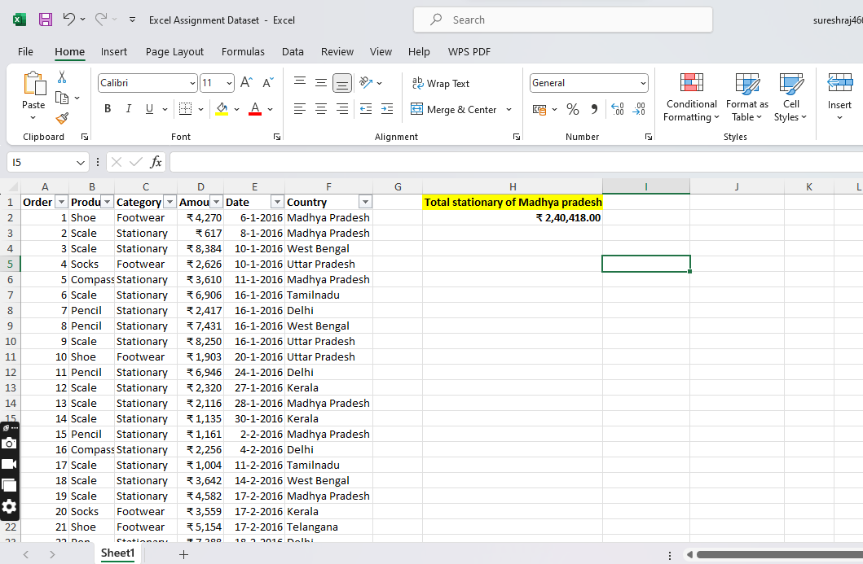

2. What is the total count of stationary bought from Tamilnadu?

Answer: 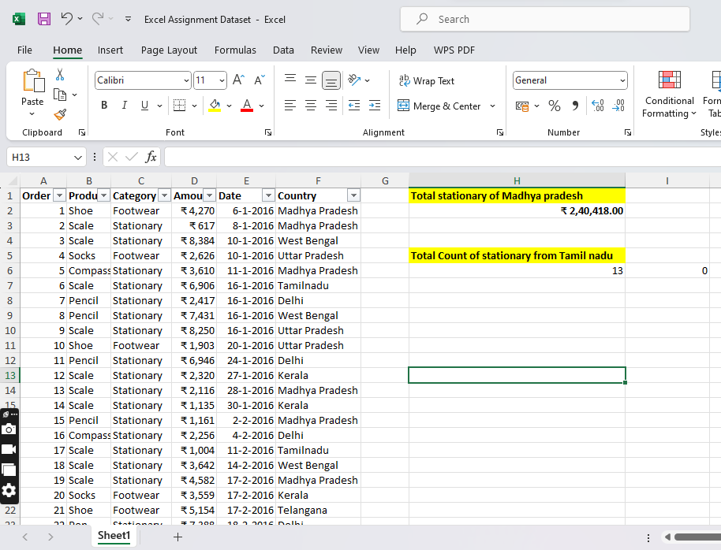

3. What is the total amount spent on footwear?

Answer: 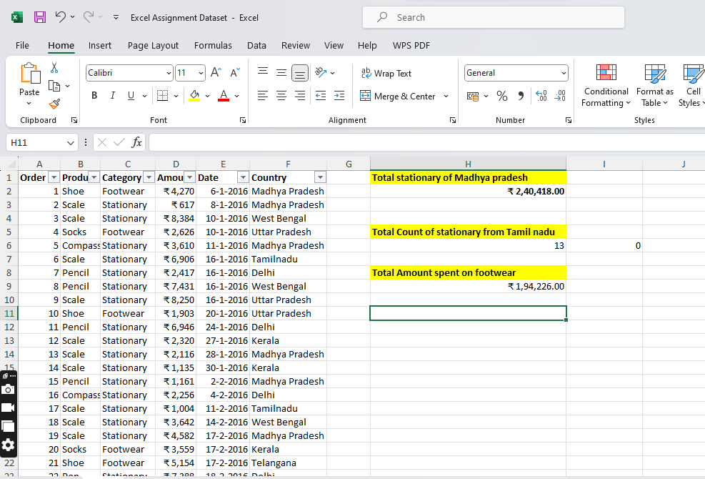

4. What is the total amount of money spent for stationary in July?

Answer: 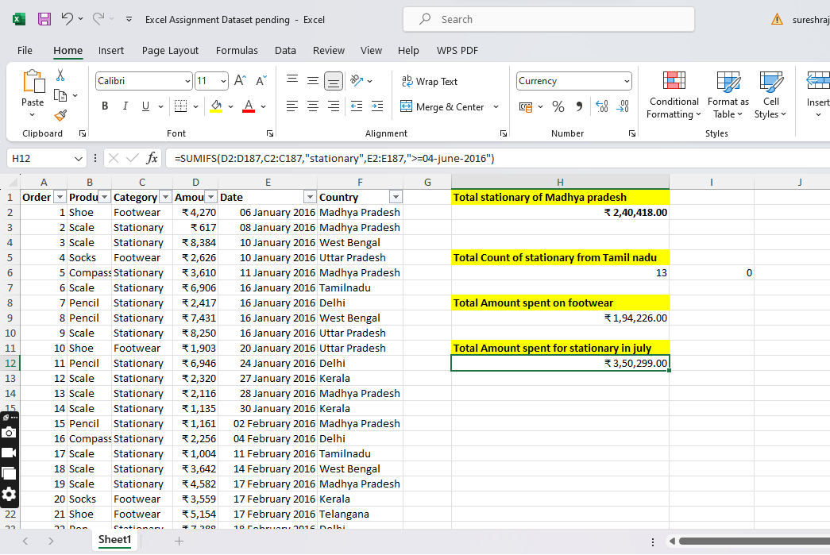

5. What is the count of footwear that is coming from Delhi?

Answer: 